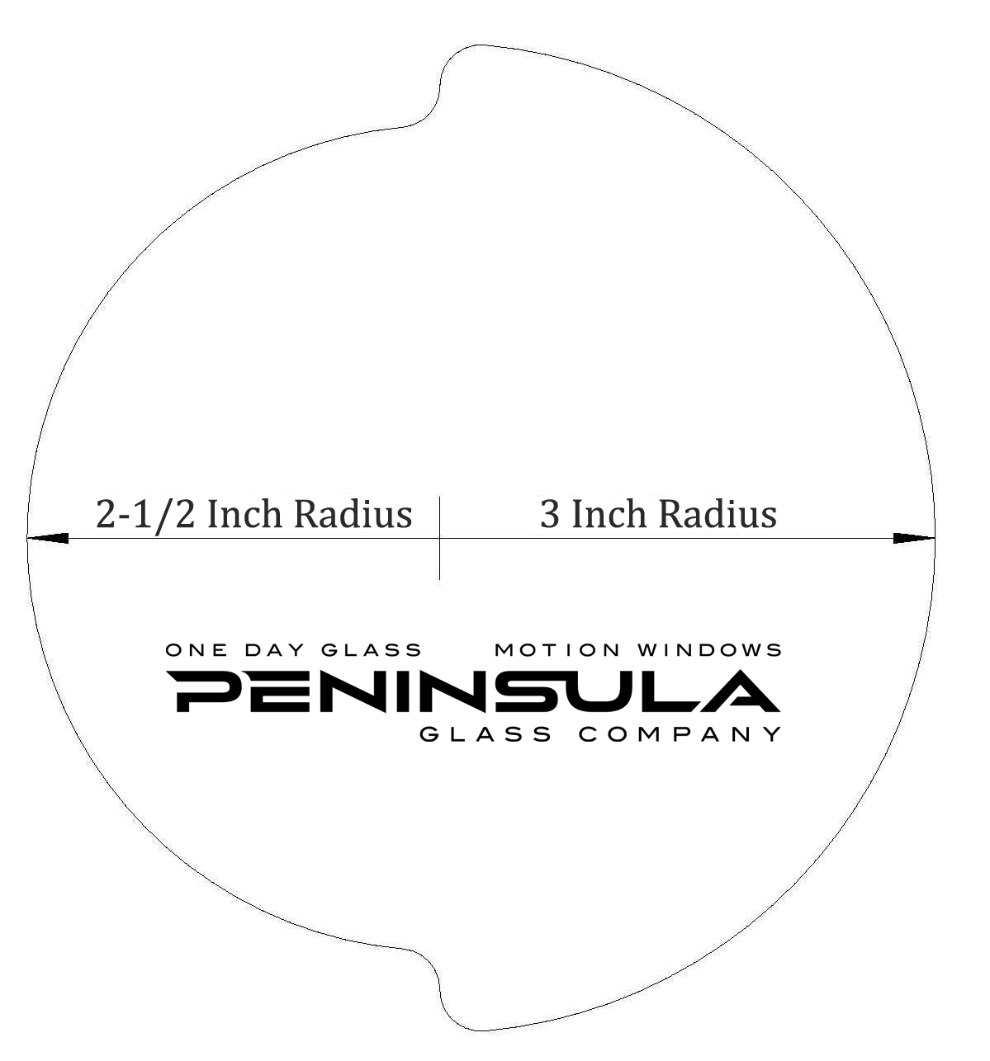
Instructions: When printing, please do not reduce the size of the picture. Some printers have a Print to Fit Option. Verify that the option “Print to Fit Page” is NOT selected if this option is available.
PRIOR TO USING: After printing, please verify that the template is the correct size by measuring with a tape measurer or ruler from arrow to arrow. The measurement should be 5 ½ Inches. If it’s not then you have not printed the template to its original size. Please look at your printer settings.
Carefully cut out along the line and your measuring template will be ready to use.

